
HARROW COUNCIL

ADDENDUM

PLANNING COMMITTEE

DATE: 30th June 2021

1-01 | Addendum Item 1  Loss of Existing and Community Sports Facilities  Update to paragraph 6.2.60 (Page 64)  Further comments have been sought from the Greater London Authority in respect of policy S5 of the recently adopted London Plan 2021. This new policy is much more explicit than the previous London Plan policy (London Plan (2016) policy 3.19) and paragraph 97 of the NPPF (2019) which considers how the loss of sports facilities/recreation land should be assessed. This clarifies that sports and recreational land should be retained unless an assessment has been undertaken in relation to existing need or alternative sports and recreation provision if the existing use is no longer required. The previous extant appeal decision didn’t consider the need for alternative sport/recreation uses in the borough as this wasn’t explicitly required or set out. As such, officers consider the current recently adopted London Plan policy S5 is relevant to the consideration of this assessment in respect of consideration of alternative sports provision. It is noted that this policy was not commented on by the Greater London Authority as the author of the London Plan in their Stage 1 report on the application. As such, officers have sought clarity on this issue from the GLA who have advised that the stage 1 report pre dated the now adopted London Plan and in the event that the application is referred back to them (should the application be granted), an updated policy assessment of this policy would be included at stage 2.  Whilst the applicant has explored the need for retention of the existing use which has been informed by the adopted Harrow Outdoor Sports Strategy (2013), there has been no consideration of the need for alternative sports provision on the application site, taking account of the borough needs (either in respect of indoor or outdoor sports provision). In light of the above, it is considered the proposal fails to comply with paragraph 97 of the NPPF (2019) and policy S5 of The London Plan 2021 and the following additional reason for refusal is recommended:  The proposed development in the absence of the assessment which clearly shows that the existing sports and recreational land or facilities to be surplus to requirements for provision of alternative sports and recreational provision at the local and sub regional level taking into account the borough’s assessment of need, fails to comply with the National Planning Policy Framework (2019) and policy S5 of the London Plan (2021).  Additional Comments from Brockley Hill Resident Association:  - Events will end at 1am on Friday and Saturday and at midnight of weekdays  - There is insufficient space for more than 2 to 3 coaches to be on site any one time  - The access can’t be amended to improve safety as the applicants do not own the land  - Vehicle waiting to enter the site from Brockley Hill will be a hazard  - Safety concerns of speeding traffic down Brockley Hill  Other comments:  - Fails to support night time economy of town centre  - Inappropriate entrance and exit layout  - Excessive building size  - Concerns over archaeological remains  - Singular faith establishment, not open to all residents  - The golf club is up for sale which brings into question the statement the applicants have made about the application and regarding parking.  - The site is up for sale and being promoted for residential use for over 230 homes or a leisure facility which would be a gross overdevelopment.  Officer Response:  - The applicant has outlined the banqueting facility would close at 12pm midnight but it remains unclear if this is everyday. Had the proposal been considered acceptable in other regards, a condition would have been added in line with the recommendations of the Council’s Environmental Health Department (7am-12midnight Mon-Sat, Sundays and bank holidays – 8am-11pm).  - The access has been designed to accommodate simultaneous ingress and egress by coaches, ensuring that vehicles are not held up on Brockley Hill. Some events will involve a higher proportion of guest trips by coach than by car and coaches would be able to park perpendicular to car parking bays. It is acknowledged that coach car parking can be encouraged but cannot be forced and as such the Highways Authority has concerns of overspill parking.  - Had the application be considered acceptable alterations and improvements to the site entrance could have been secured through section 106/S278 agreement.  - The Highways Authority do not consider that the proposed use will result in an increase in accidents over and above the former use a golf facility. Nevertheless, mitigation could be put in place to improve the existing situation, e.g signage, site access, pedestrian crossing and soft measures to promote access routes to the venue/travel planning.  - The proposal is for a banqueting facility as a sui generis use and has been assessed accordingly. The proposal is a private business and the LPA would have no control over the users of the facility.  - Concerns regarding archelogy, town centre development and building scale are considered in the main appraisal.  - The issue of the sale of the land is not a material consideration and is a private matter for the landowners. Should the application be granted, the development would need to be undertaken in accordance with the approved plans and documents and any relevant planning obligations.  Informatives Page 91  Add the following to the Informatives list:  Other Relevant Guidance:  Harrow Outdoor Sports Strategy (2013)  Harrow Indoor Sports Facility Strategy (2018-2026)  Plans and Document List (Page 92)  Active Travel Zone, Healthy Streets Photo Survey (dated August 2020) by EAS; Sequential Site Assessment Supplementary Note (dated March 2021); Outline Construction Logistics Plan (dated August 2020) by EAS; Sequential Site Assessment (dated August 2020) ; Brockley Hill Life Cycle Assessment BREEAM RIBA Stage 2 by Eight Associates; Preliminary Assessment BREEAM 2018 New Construction by Eight Associates; RIBA Stage 2 Overheating Analysis; Delivery and Servicing Plan (dated August 2020) by EAS; Design and Access Statement (dated 26th August 2020) by 5 plus; Supplementary Design and Access Statement (dated 28 January 2021) by 5 plus; Ecological Assessment (dated 28th January 2021) by Tyler Grange; RIBA Stage 2 Energy Assessment by Eight Associates; Planning Statement (dated August 2020) by hgh; Travel Plan and Car Park Management Plan (dated August 2020) by EAS; Accurate Visual Representation for Photoviewpoint 1; Archaeological Desk Based Assessment Ref: 6129A (dated January 2021) by HCUK Group; Flood Risk Assessment and Drainage Strategy (dated January 2021) by EAS; Landscape and Visual Appraisal (dated 28th January) Ref 13201/R02e/RP/JJ by Tyler Grange; Noise Impact Assessment Revised 20th January 2021 Ref: 89421 by NSL Noise Solutions Ltd; Supplementary Planning Statement (dated January 2021) by hgh; Transport Assessment (dated January 2021) by EAS; TPP/BHGCBHS/010 B Tree Protection Plan; Brockley Hill Sequential Site Assessment – Supplementary Note (dated September 2020); Arboricultural Report by David Clarke Chartered Landscape Architect (dated January 2021)  B1_02_2001 Rev 05; B1_04_2000 Rev 02; B1_04_2000 Rev 03; B1_02_2000 Rev 05; B1_02_2002 Rev 04; B1_02_2002 Rev 05; B1_05_2000 Rev 05; MP_00_0004 Rev 07; 13201/P11d (Landscape Strategy Plan); B1_02_2200 Rev 07; B1_02_2201 Rev 07; B1_02_2202 Rev 07; B1_04_2200 Rev 04; B1_04_2201 Rev 04; B1_05_2200 Rev 07; B1_10_4200 Rev 02; B1_10_4201 Rev 02; MP_00_0003 Rev 07; MP_00_0200 Rev 19; MP_00_0300 Rev 04; MP_00_2200 Rev 16;  Local CIl Requirement Page 27:  Update local CIL requirement to £0  Page 25 – Validation Date :  Amend to 1st September 2020  Addendum Item 2:  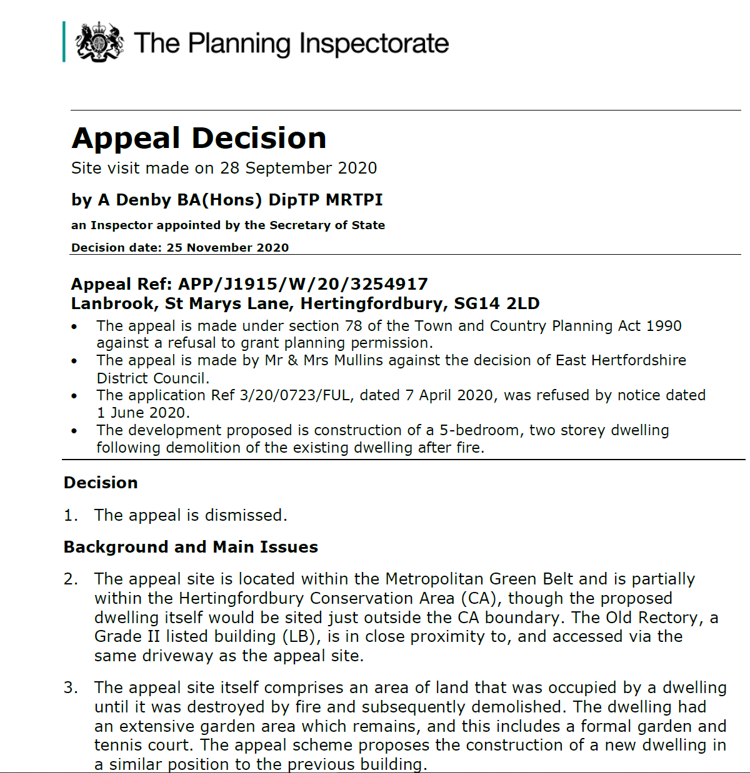  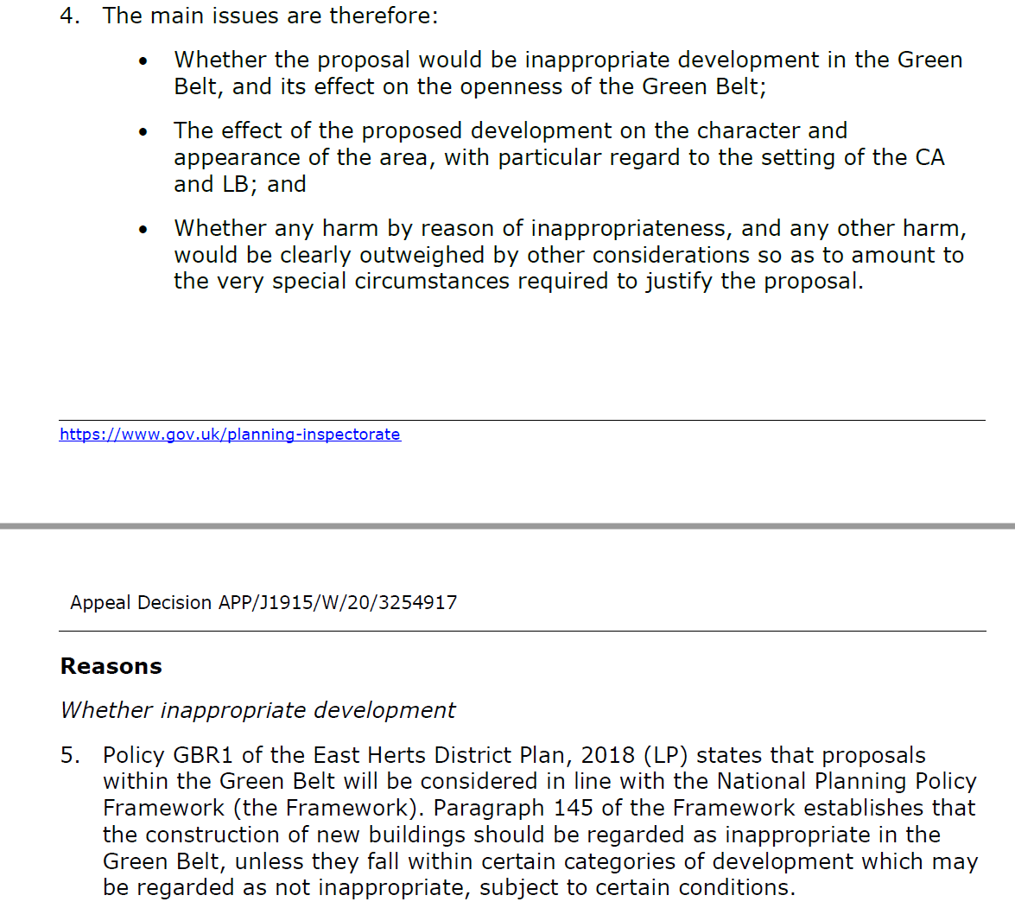  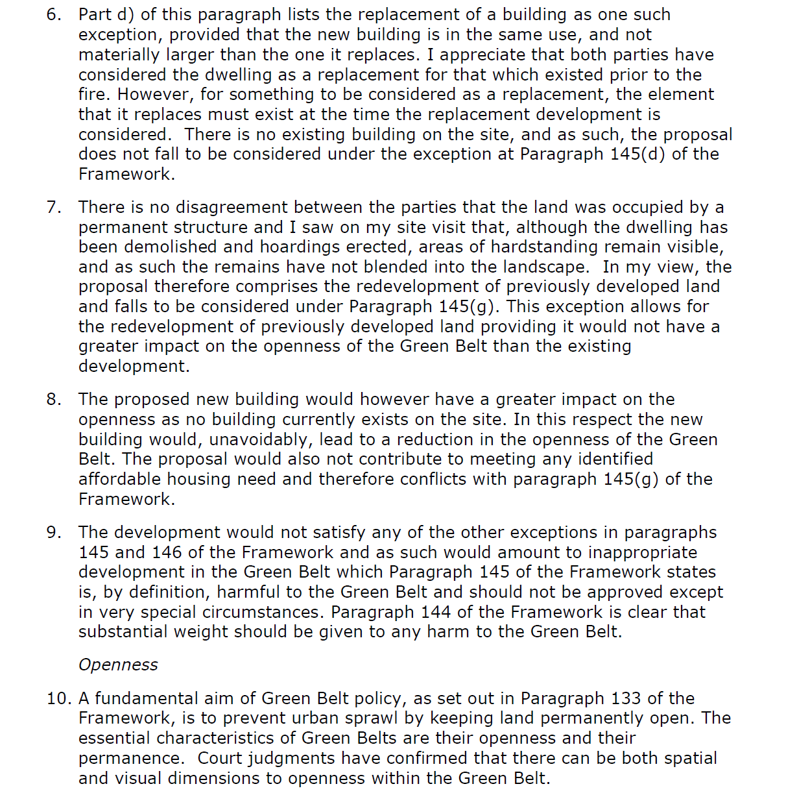  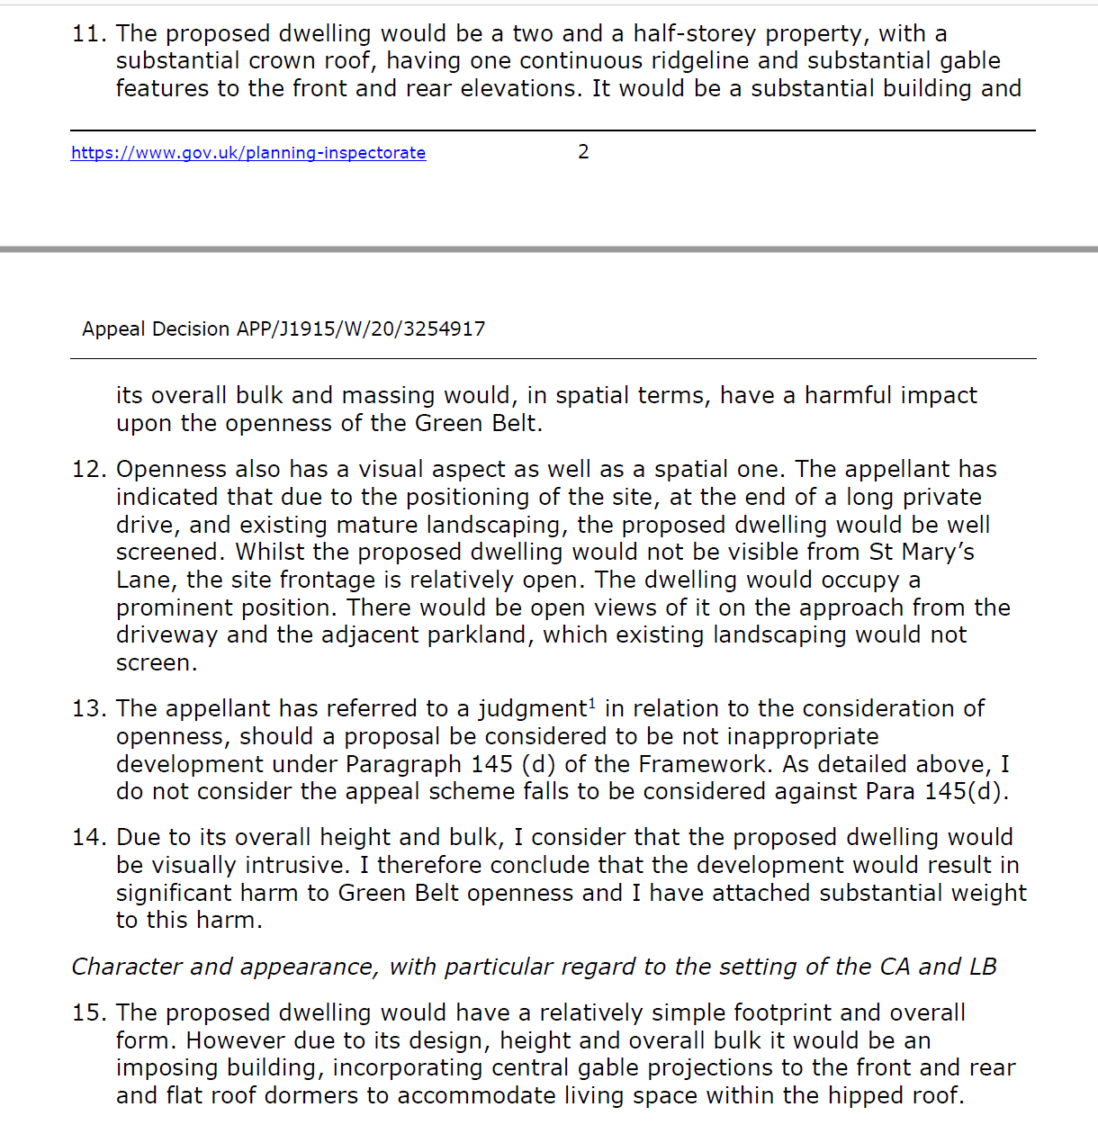  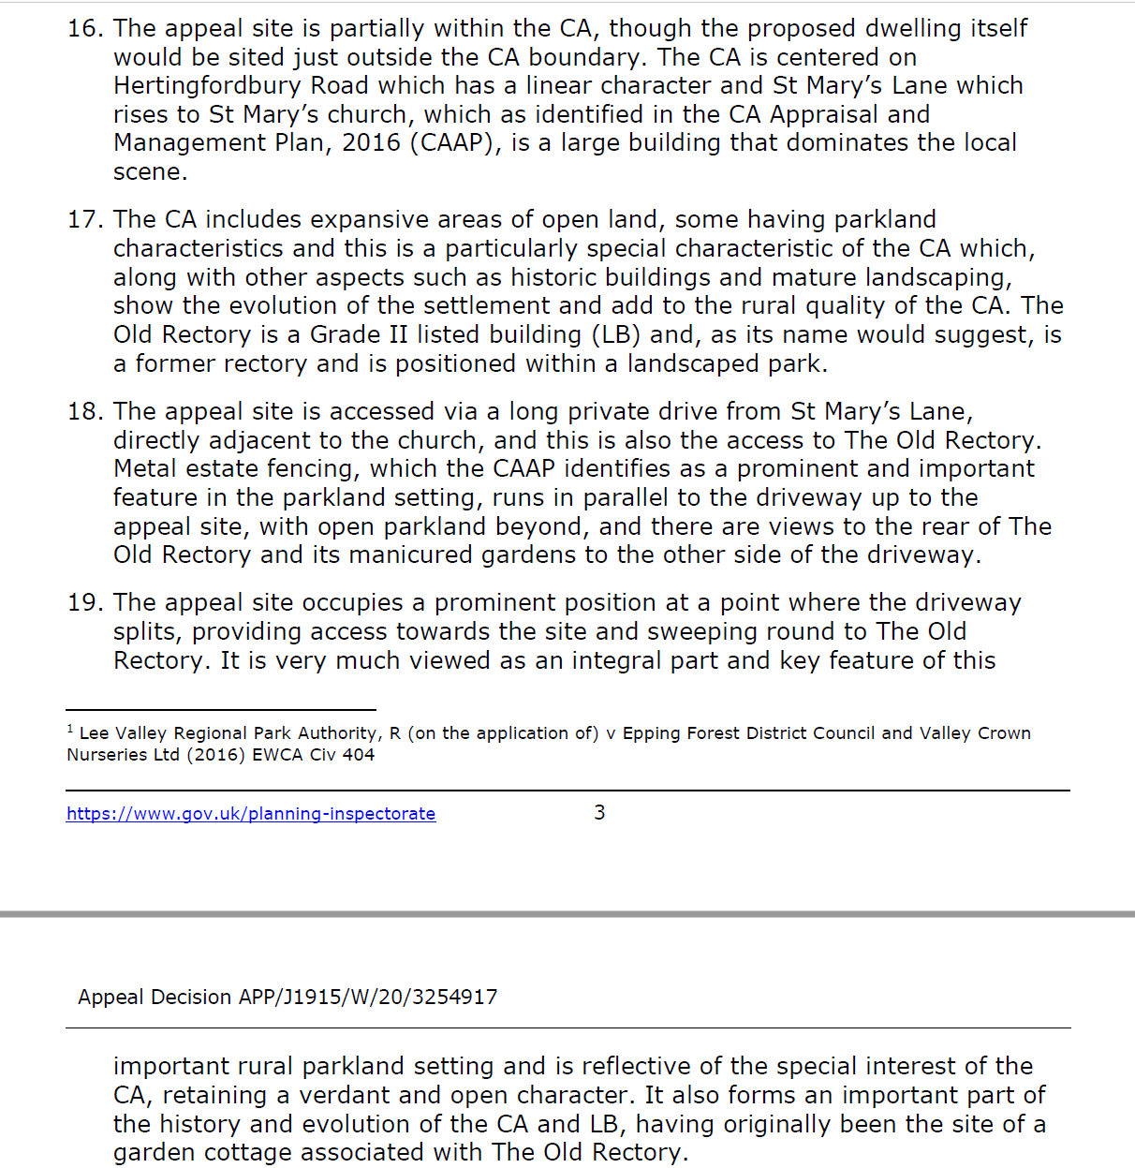  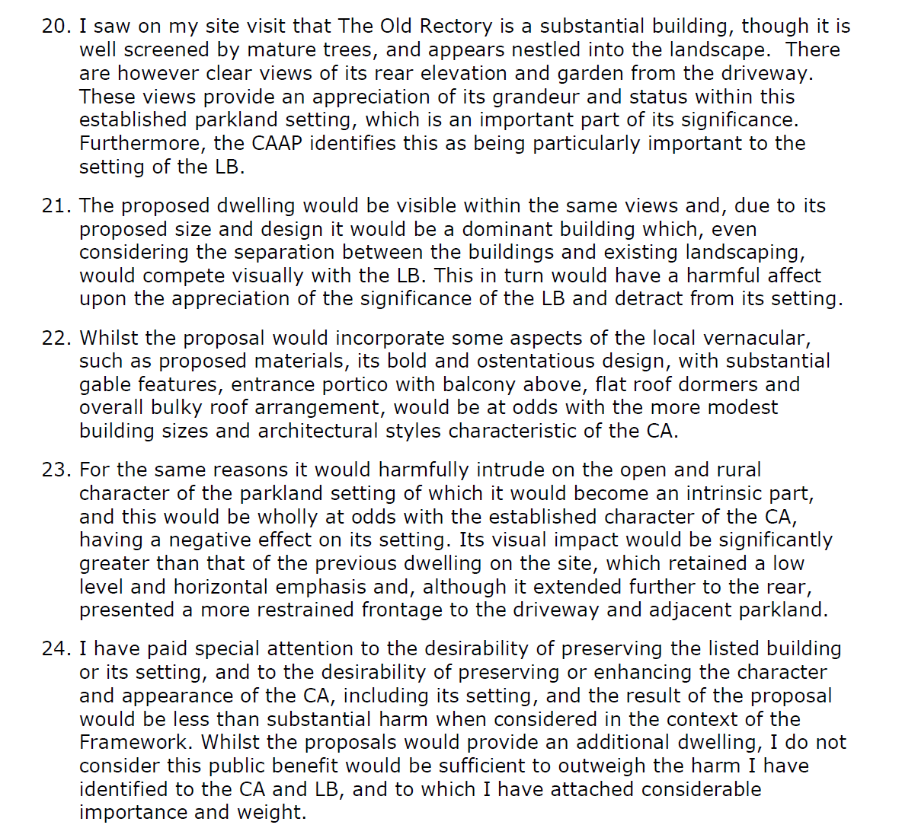  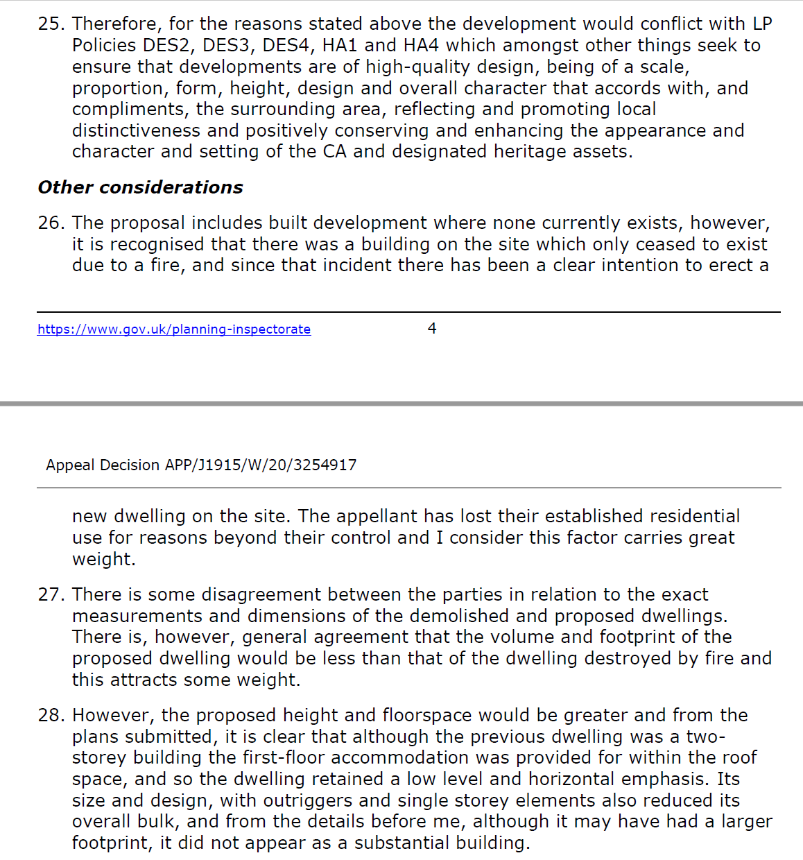  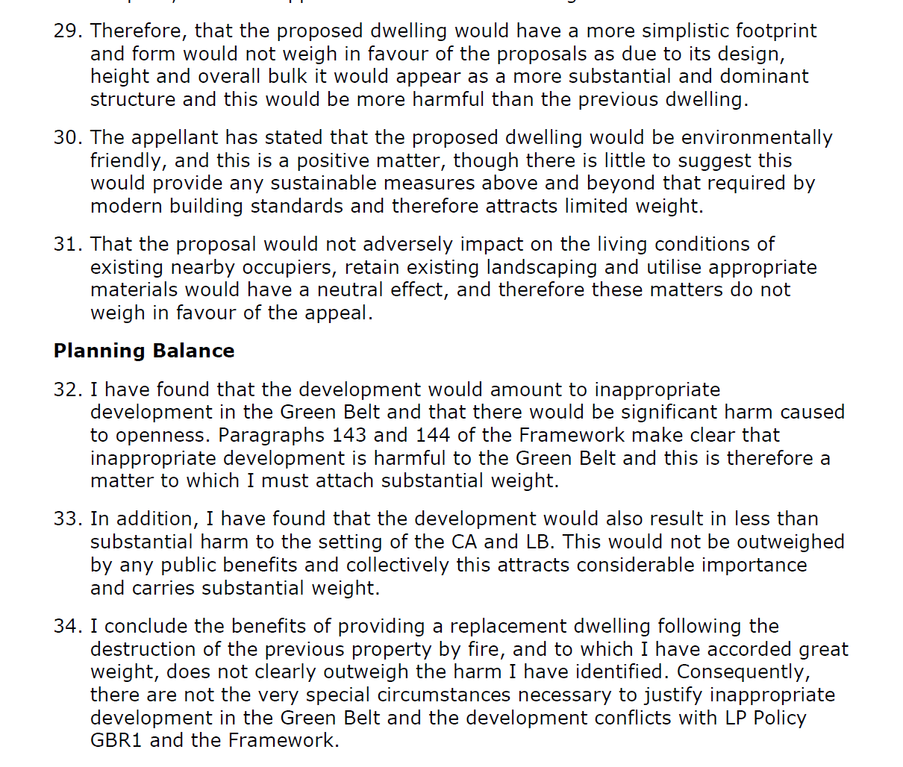  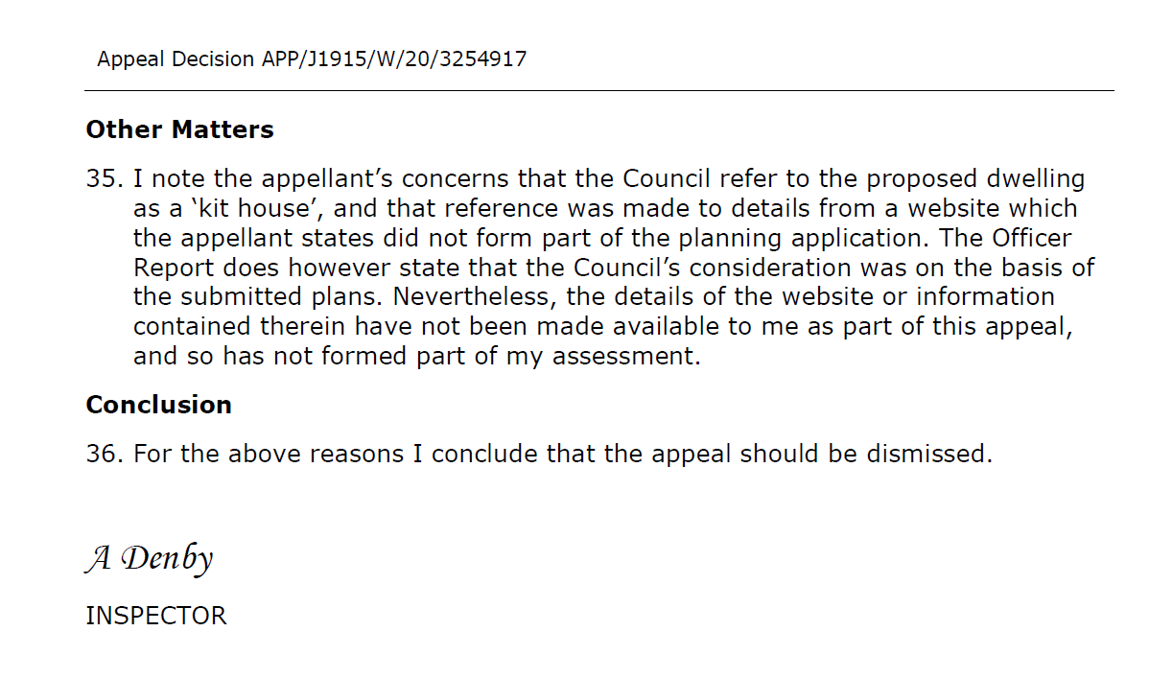
2/01 | Addendum Item 1:  Alteration to paragraph 2.5 from: ‘The proposal is car free’ to ’The proposal does not provide any off-street parking spaces.’
2/02 | Addendum Item 1:  Paragraph 4.3, within consultation box under ‘other matters’, and ‘intrusion over shared boundary’ additional info to be added as follows:  The objectors at No.46 were informed that the plans had been revised to remove intrusion over their boundary, via email on 30th March 2021  Paragraph 6.3.6: to be updated to replace ‘Southfield Park’ with ‘Blythwood Road’.
2/04 | Addendum Item 1  Paragraph 2.1: to be updated to replace ‘rooflights’ with ‘Solar panels’  Paragraph 6.3.10 (and associated heading) to be updated to read:  Rooflights  6.3.10 Three separate arrays of solar panels are proposed on the rear and side elevations. As these are angled to match the roofslope, they would not introduce any adverse visual or amenity impact to the streetscene or neighbours.  Page 191 of the agenda, bottom set of elevations to be labelled as ‘Proposed Side Elevation’ and ‘Proposed Rear Elevation’ (in that order)
2/05 | Addendum Item 1  The proposed wording to Condition 4 should be amended as follows to correct the previous wording specific to works adjacent the swamp cypress tree:  - Trees  The proposed development shall be undertaken in accordance with the recommendations outlined in the approved Arboricultural Impact Assessment [ref: 101 467, updated 03/11/2020]; including the pre-commencement meeting to take place between the consultant and site manager, no-dig surfacing and other particulars relating to protecting of the tree. All protective measures shall be in place before any equipment, machinery or materials are brought on to the site for the purposes of the development, and shall be maintained until all equipment, machinery and surplus materials have been removed from the site. Nothing shall be stored or placed in any area fenced in accordance with this condition, and the ground levels within those areas shall not be altered, nor shall any excavation be made, without the written consent of the local planning authority. No works to tree, including their removal of lopping shall occur between the months of March to August (inclusive).  REASON: To safeguard the trees near the site of amenity value and mitigate the impact of development on local ecology and in the interests of site ecology.
2/06 | Addendum Item 1  Consultation  Update to paragraph 4.4  Following additional issues raised by an objector, received on the 28th June 2021, additional text is added to the summary table.  Character and Appearance  Amendment to 6.3.2 to confirm how the parking is arranged  6.3.2 The proposed car park has been amended during the course of the application from tarmac to Bodpave. The latter is a permeable surface and will be infilled with a soil mix and grassed so that it would allow for a more sympathetic appearance given the  Green Belt context and the proposed occasional use. Furthermore, there would be no markings on the ground defining individual parking spaces, the area would replicate that of an open grass area when not in use. When the overspill car park area is in use for large events parking stewards would direct vehicles to park accordingly. These details were approved under reference P/4255/19 related to the permission for the 3G pitches at the sports centre (P/4748/18). On this basis, officers consider that the proposal would not harmfully detract from the character or appearance of the area and would accord with the relevant policies in this regard.  Landscaping, Trees, and Ecology  Additional paragraph to be added to describe details of the Bodpave  6.7.4 Bodpave is a durable product that has a lifespan of approximately 20 years when in used with standard size vehicles. It is a high quality product and the product is made from UV stabilised material. A condition is to be added to ensure the upkeep of the ground material during the lifetime of the development.  Appendix 1 – Conditions  - Amendments to Condition 2 as follows to account for additional details  Approved Plans and Documents  The development hereby permitted shall be carried out, completed and retained in accordance with the following approved plans and documents:  C17-001E, Transport Post Application Technical note (September 2019), Design and Access Statement (August 2019 Rev B), Bodpave 85 Porous.  REASON: For the avoidance of doubt and in the interests of proper planning.  - Removal of Condition 5 as these details have already been provided and approved as part of the Approval of Detail application P/4255/19 relating to the 3G pitches approval at Roger Bannister Sports Centre (P/4748/18).  - Add a new condition 5 relating to the upkeep of the Bodpave over the lifetime of the development as follows,  Maintenance of the Ground Treatment  The ground treatment as indicated on the submitted Site Plan (C17-001E) identified as Bodpave shall be permanently retained, and maintained, during the lifetime of the development.  REASON: To safeguard the permeable and sympathetic ground treatment.
  Summary of Comments on original consultation
  Concerns of wrong details being approved. Concerns over the design of the Bodpave and how parking spaces will be indicated on the ground.
  Officer response: Officers have reviewed the details to be approved and added further document to the approved documents condition. The details of the Bodpave is shown on the submitted site plan. Further technical information has been submitted, and further commentary has been provided within this addendum. Parking spaces are not proposed to be indicated as when not in use the parking area should appear as an open grass area. On large events days parking stewards will manange the cars coming into and out of the overflow area.
AGENDA ITEM 10 – REPRESENTATIONS ON PLANNING APPLICATIONS

Agenda Item |  | Application | Speakers
1/01 |  | Stanmore and Edgware Golf Centre | Councillor Ameet Jogia (Back Bench)
2/01 |  | 56 Lorne Road | Bekim Haziri (Objector)  Muneer Ahmed (Agent for Applicant)
2/02 |  | 44 Blythwood Road | Alexandra Osborn (Objector)  Applicant/Agent (To be Advised)
2/05 |  | West House Gallery Café, West End Lane | Jackie Lindop (Objector)  Applicant/Agent (To be Advised)

